Before running the program run the sql code in mysql CLI.

Drop database if exist fareDB;

Create database fareDB;

Use fareDB;

Commit;

After that make some changement in Application.properties file(use your mysql db username & password).

To check the functionality of REST API

For post Mapping

Use the address: <http://localhost:8080/fare>

In form of json data e.g.

{

    "startStation":"Sasaram",

    "destinationStation":"Danapur",

    "fare":80

}

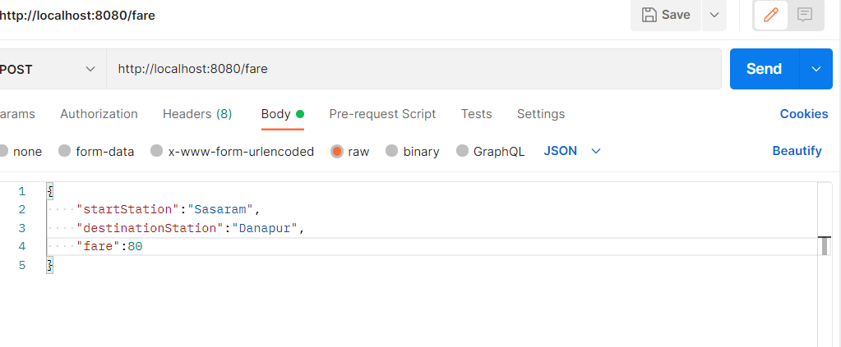

For Get Mapping

Use the address :

<http://localhost:8080/fare> (for fetch all data)

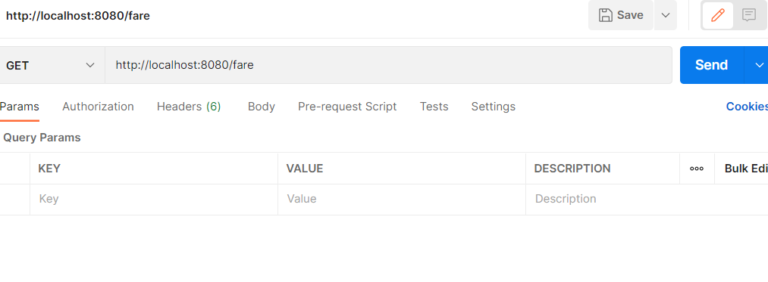

For Get Mapping

Use the address :

<http://localhost:8080/fare/ds/DESTINATION_STATION_NAME/SOURCE_STATION>_NAME

**This is for fetch fare from destination station to start station**

